**KOOSKIA CITY COUNCIL**

**PUBLIC HEARING/REGULAR MEETING**

**NOVEMBER 13, 2024**

**6:00 P.M.**

**Public Hearing**

1. Call to Order
2. Notice of Public Hearing on Proposed Grant Activities to submit a proposal to the Idaho Department of Commerce for a block grant in the amount of $500,000 for the final phase of the sewer/wastewater system improvements. Adjourn Public Hearing
3. Adjourn

**Regular Meeting**

**Amendments:** Final action cannot be taken on an item added to the agenda after the start of the meeting unless an emergency is declared that requires action at the meeting. The declaration and justification must be approved by motion of the Council.

1. Call to Order
2. Presentation of Minutes Action Item
3. Sheriff’s Report
4. Presentation – Amy Manning – III-A Trust Annual Report

5. **UNFINISHED BUSINESS**

a. Sewer/WWTP updates Action Item

b. Nuisance Property Violations Action Item

c. Park Grant Action Item

d. Kiosk maintenance update

6. **NEW BUSINESS**

1. Ambulance Stipend Increase Action Item
2. ES building cement safety bollards Action Item

c Retain Presnell Gage for the 23/24 Audit Action Item

1. Write-off accounts Action Item
2. Re-schedule December Meeting Action Item
3. Grocery Gift Cards for Christmas Action Item

7. The Council is asked to allow payment of the bills Action Item

8. Reports – Mayor Ulmer completed the Blue Cross Mayor walking challenge

9. Adjournment

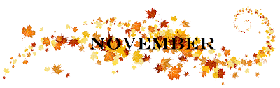

Any person needing special accommodations to participate in the above noticed meeting should contact the City of Kooskia at least 24 hours in advance at 208-926-4684